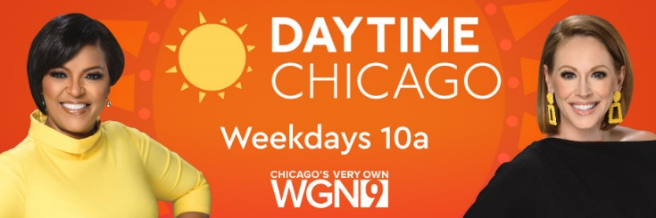

October 24, 2022

Byline: Sandra Guibord

[Link](https://wgntv.com/daytime-chicago/halloween-candy-and-wine-pairings/)

